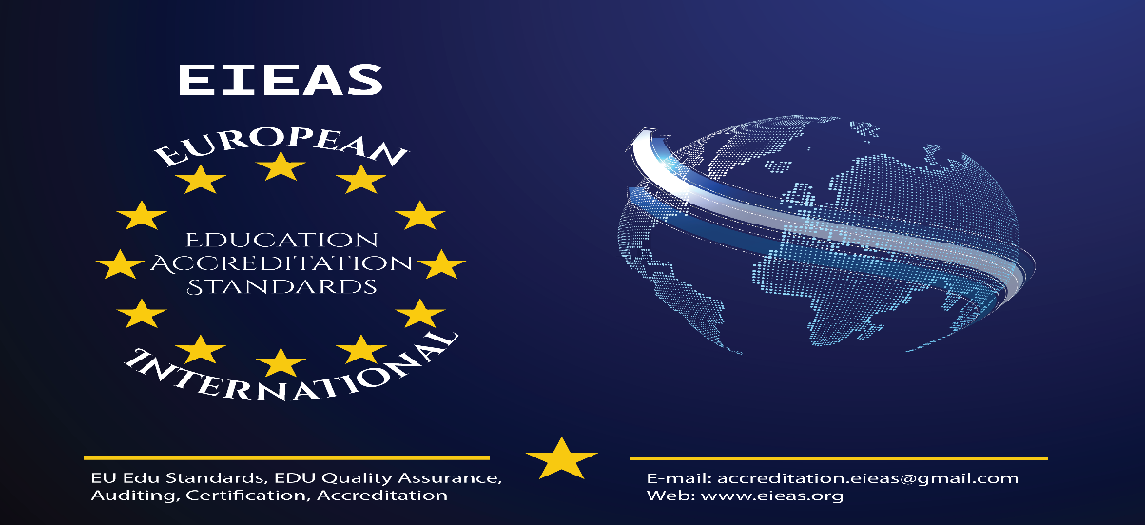
European International Higher Education Accreditation and Quality Assurance Agency

APPLICATION FORM FOR ACCREDITATION

(This form shall be completed, signed, stamped required to be submitted to the EIEAS Accreditation Committee Head for further processing and a copy is given to the applicant for confirmation)

Program Accreditation – (For Existing Institution)

Date applied: Day Month year (Eth. Calendar)
- Background Information

Name of Institution:

Address: Location and Campus:

Tel: Office Mobile

Fax: E-mail:

Responsible Contact Person:
Designation:

Tel: Office Mobile

Fax: E-mail:

Program Level: Undergraduate Graduate

Program Level: Diploma [ ] , Advanced Diploma [ ] , Graduate Diploma [ ], Post Graduate Diploma [ ]
Training Courses: Short Training Program [ ], Professional Training Program [ ]

List of Training Programs applied for:

OR

List of programs applied for:

Planned Mode of Delivery: Regular Distance

- Documents Submitted upon Application

Sl. No. | Documents on requirements | Submission status |  | Remark
 |  | Yes | No
1 | Application letter
2 | Annual plan
3 | Need assessment on the program(s) /workshop proceeding
4 | Curriculum for program (s) |  |  | One curriculum for  each program
5 | Course materials/modules for distance delivered programs |  |  | For distance programs
6 | Module writing, tutor training, tutoring manuals
7 | Evidence on payment
8 | Offices and program facilities |  |  | Could be submitted after the 10 days – 20 days of this Program Application Submission
9 | Academic and technical staff for the program
Note: For a new program, relevance should be proved through stakeholders’ consultation on which workshop proceeding should be presented. Otherwise, a need assessment is enough.
Conditions of acceptance:
  - Application shall be accepted conditionally only when all documents from 1-7 are submitted up on application and documents from 8-9 are submitted in the time as specified in the table above.
  - As a failure to submit any one of the documents from 1-7 results in automatic rejection of the application, the Agency shall claim application fee.
  - Evaluation shall not be processed and hence canceled if all the documents are not submitted in the prescribed time in (1): Consequently, the application fee will not be refunded under any circumstances.
  - Presentation of all the (9) documents does not guarantee a qualification for field visit but Video conference call for the verification part may be arranged: A thorough screening shall be made and the respective institution will be informed formally to fulfill any missing requirements in 10 days as of the issuance day of the letter.
  - EIEAS reserves the right to amend or update its terms & conditions time to
time whenever required.

Submitted by: Name -------------------------------------Date: (d/m/y) / /

Signature-------------

Checked by: Name ----------------------------------Date: (d/m/y) / / Signature----------------

Official Seal

